Session 17: RDD'S IN SPARK
Assignment 17.2

Problem Statement
Problem Statement 1:
1. Read the text file, and create a tupledrdd.
2. Find the count of total number of rows present.
3. What is the distinct number of subjects present in the entire school
4. What is the count of the number of students in the school, whose name is Mathew and
Marks is 55

Problem Statement 2:
1. What is the count of students per grade in the school?
2. Find the average of each student (Note - Mathew is grade-1, is different from Mathew in some
other grade!)
3. What is the average score of students in each subject across all grades?
4. What is the average score of students in each subject per grade?
5. For all students in grade-2, how many have average score greater than 50?

Problem Statement 3:
Are there any students in the college that satisfy the below criteria:
1. Average score per student_name across all grades is same as average score per student_name
per grade
Hint - Use Intersection Property.

Dataset
Given a dataset of college students as a text file (name, subject, grade, marks):
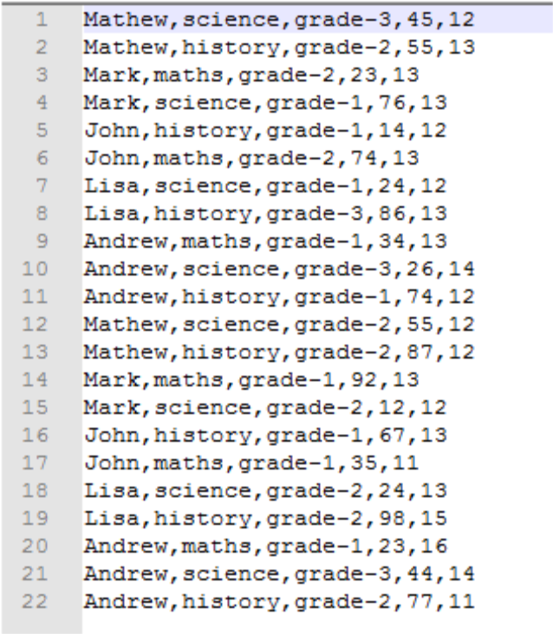

Spark Operations – Problem Statement 1

Task 1.1 Read the text file, and create a tupledrdd.

Below is the code we use to read the text file using spark context and creating a tuple RDD,
scala>valbaseRDD = sc.textFile("/home/acadgild/hadoop/17.2_Dataset.txt").map(x =>
(x.split(",")(0),(x.split(",")(1),x.split(",")(2),x.split(",")(3).toInt,x.split(",")(4).toInt)))

scala>baseRDD.foreach(println)
We have create a tuple RDD with name as Key and the subject, grades and the marks as values.
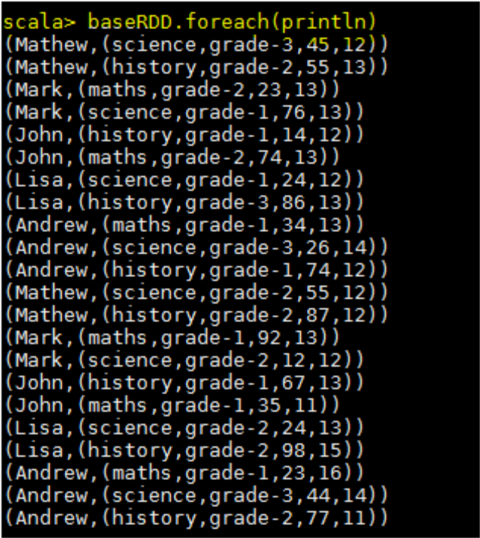
Task1.2 - Find the count of total number of rows present

scala>baseRDD.count()

res1: Long = 22

By using count() function we can see the number of lines present in the text file.
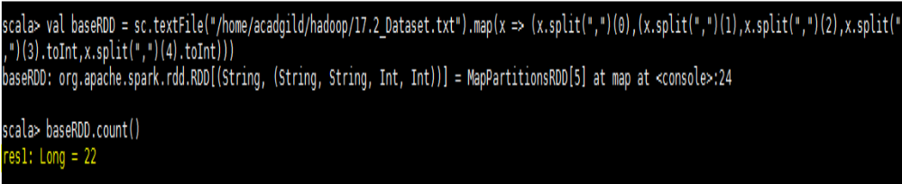
Task1.3 - What is the distinct number of subjects present in the entire school?

Please see the below codes used for this task,

valbaseRDD = sc.textFile("/home/acadgild/hadoop/17.2_Dataset.txt").map(x=> (x.split(",")(1),1))

valRDDreduce = baseRDD.reduceByKey((x,y)=>(x+y))
scala>RDDreduce.foreach(println)

(maths,6)

(history,8)

(science,8)
First we are creating a RDD to read the file and selecting only subject name and mapping them with value
1 and counting the values of occurrences using reduceByKeyto get distinct number of subjects.
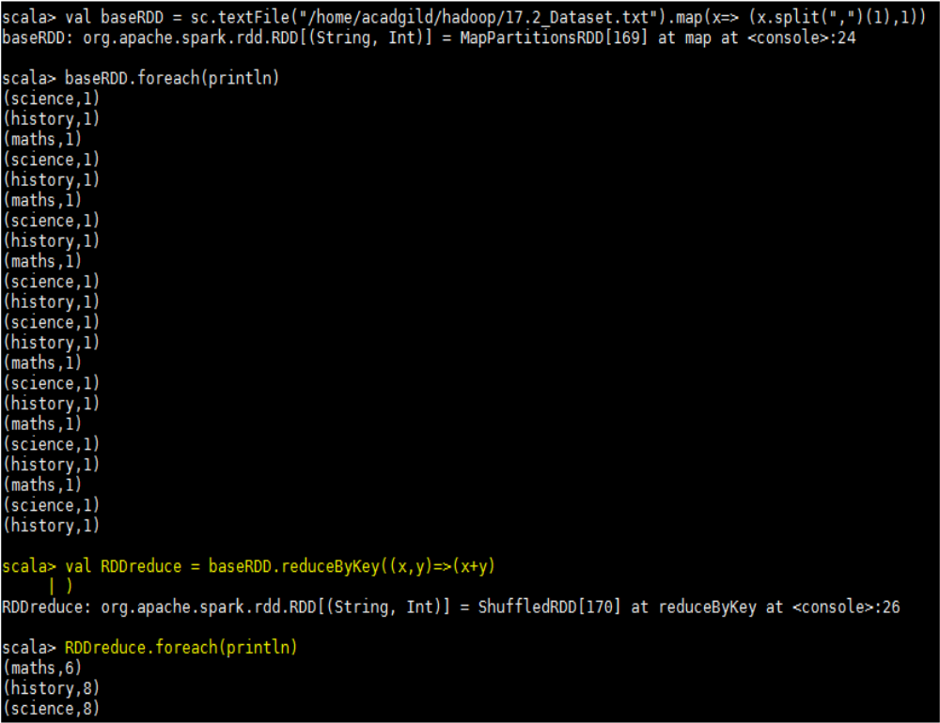
Task1.4 - What is the count of the number of students in the school, whose name is Mathew and marks is 55

Below are the codes,

valbaseRDD = sc.textFile("/home/acadgild/hadoop/17.2_Dataset.txt").map(x =>
((x.split(",")(0),x.split(",")(3).toInt),1))

valRDDfilter = baseRDD.filter(x=>x._1._1 == "Mathew" && x._1._2 == 55)

valRDDreduce = RDDfilter.reduceByKey((x,y)=>x+y).foreach(println)

In the first line code, we are reading the text file and creating a tuple RDD as “baseRDD” with name &
marks as key and mapping numerical 1 as value
.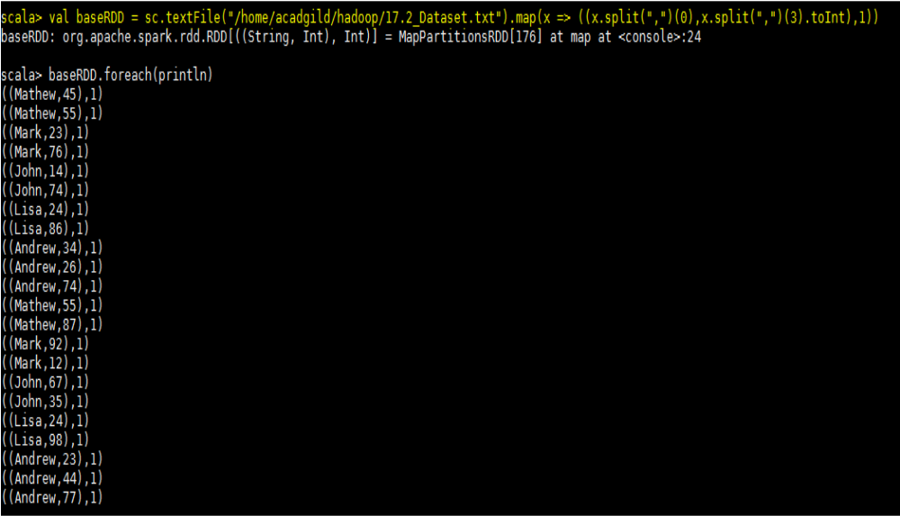
Filter the tuple RDD by providing the condition Mather and mark as 55,
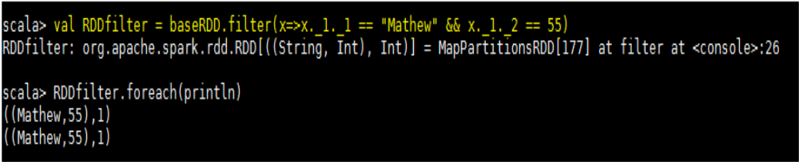

Now we are counting each occurrences using the reduceByKeyand the required output is below,
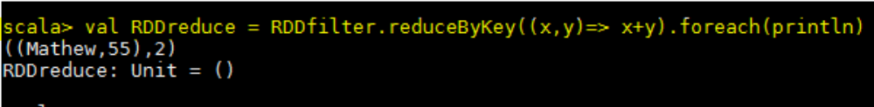

Spark Operations – Problem Statement 2
Task 2.1 - What is the count of students per grade in the school?

valbaseRDD = sc.textFile("/home/acadgild/hadoop/17.2_Dataset.txt").map(x =>
(x.split(",")(2),1)).reduceByKey((x,y)=>x+y).foreach(println)

We are reading the text file by creating a tuple RDD with grade as key and mapping numerical 1 as values and reducing the number occurrences using reduceByKey, please see the required output below,

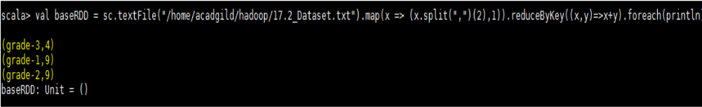

Task 2.2 - Find the average of each student (Note - Mathew is grade-1, is different from Mathew in some other grade!)
Codes,
valbaseRDD =
sc.textFile("/home/acadgild/hadoop/17.2_Dataset.txt").map(x=>((x.split(",")(0),x.split(",")(2)),x.split(
",")(3).toInt))
valRDDmap = baseRDD.mapValues(x=>(x,1))
valRDDreduce = RDDmap.reduceByKey((x,y) => (x._1 + y._1, x._2 + y._2))
valStudAvg = RDDreduce.mapValues{case(sum,count)=>(1.0*sum)/count}

First we are creating the baseRDDto read the file and selecting name and grade as key and marks as value,

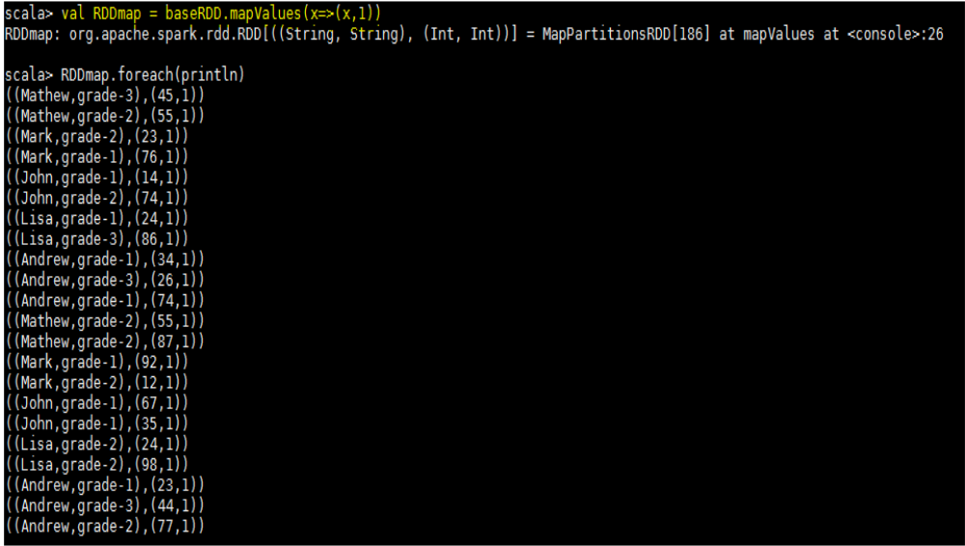

We are using reduceByKey to add the occurrences of marks for each key which is student name and grade,
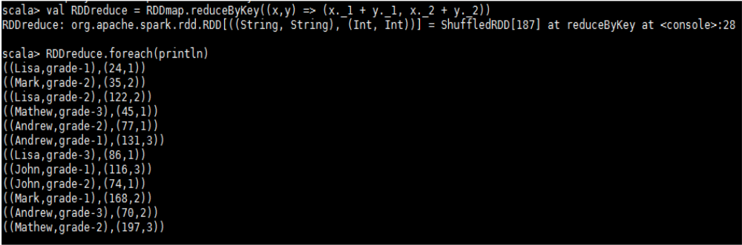

Now we are calculating average by summing the marks and dividing by its count for each key. Below
screenshot shows the final result,
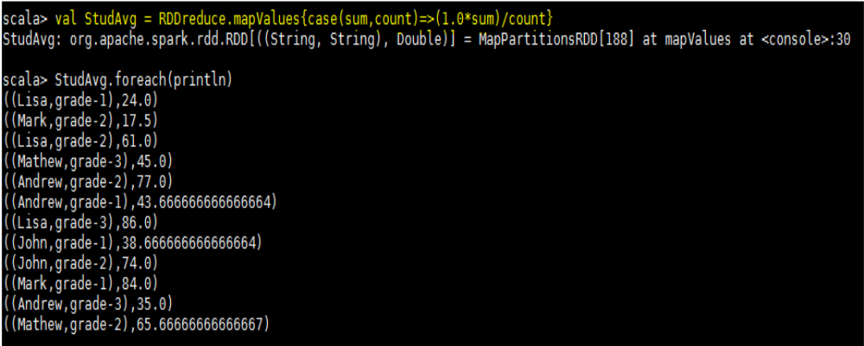

Task 2.3 - What is the average score of students in each subject across all grades?
Codes,
valbaseRDD =
sc.textFile("/home/acadgild/hadoop/17.2_Dataset.txt").map(x=>((x.split(",")(0),x.split(",")(1)),x.split(
",")(3).toInt))
valRDDmap = baseRDD.mapValues(x=>(x,1))
valRDDreduce = RDDmap.reduceByKey((x,y)=>(x._1+y._1,x._2+y._2))
valSubAvg = RDDreduce.mapValues{case(sum,count)=>(1.0*sum)/count}

We are first creating baseRDD to read the text file and we are extracting name and subject as key and
marks as value,

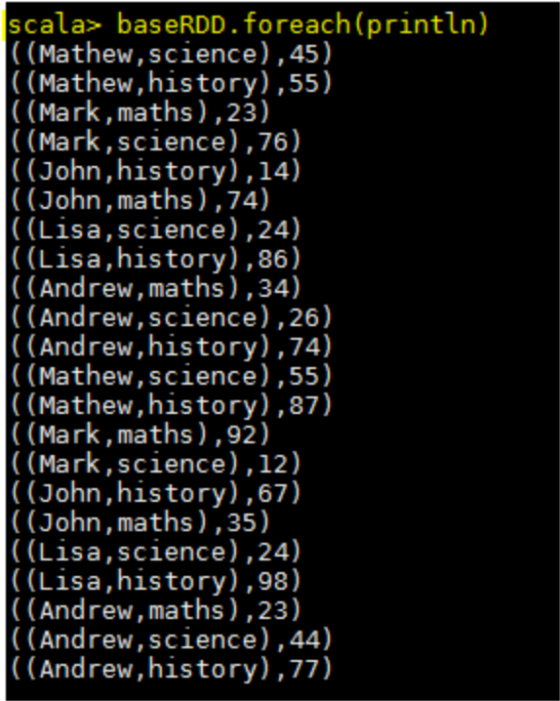
Now using mapValueswe are mapping each value with 1-
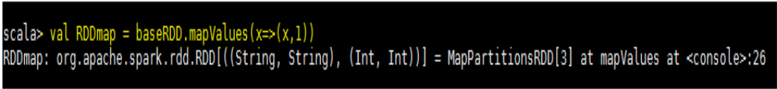
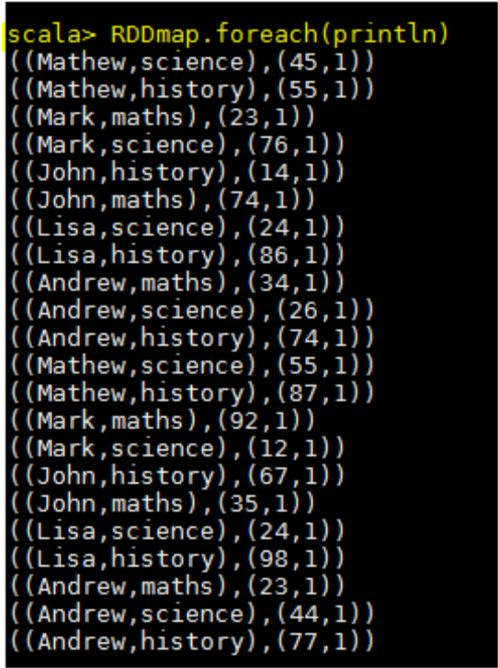
Now we are adding the marks and number of occurrences for each key using reducebyKeyand calculating average by dividing the sum of marks and count of occurrences for each key.

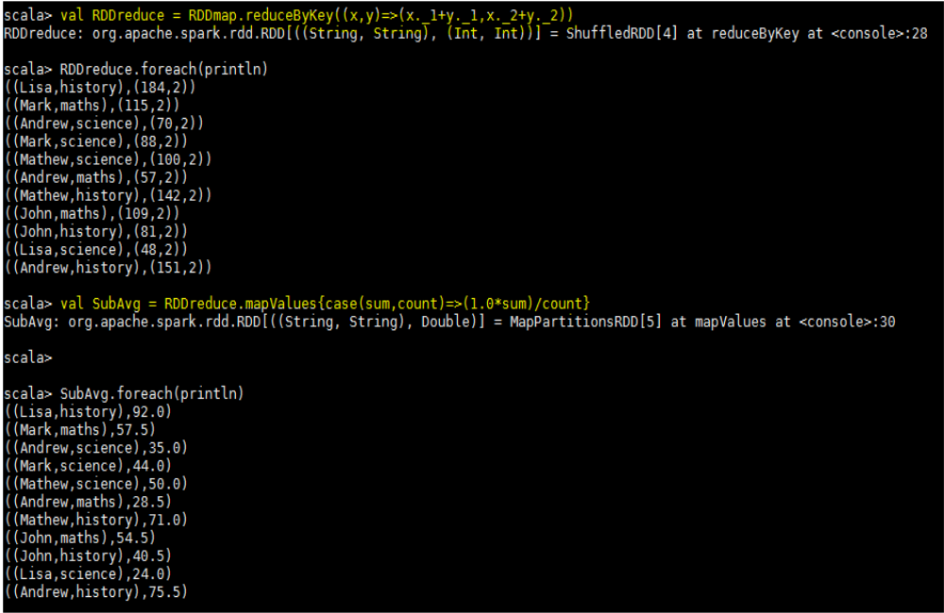

Task 2.4 - What is the average score of students in each subject per grade?
Codes,
valbaseRDD =sc.textFile("/home/acadgild/hadoop/17.2_Dataset.txt").map(x=>((x.split(",")(1),x.split(",")(2)),x.split(",")(3).toInt))

valRDDmapvalue = baseRDD.mapValues(x=>(x,1))

valRDDreduce = RDDmapvalue.reduceByKey((x,y)=>(x._1+y._1,x._2+y._2))

valAvg_Grade = RDDreduce.mapValues{case(sum,count)=>(1.0*sum)/count}.foreach(println)

In first step we are creating paired RDD named as baseRDDto read the file and extracting subject and
grade as key and marks as value
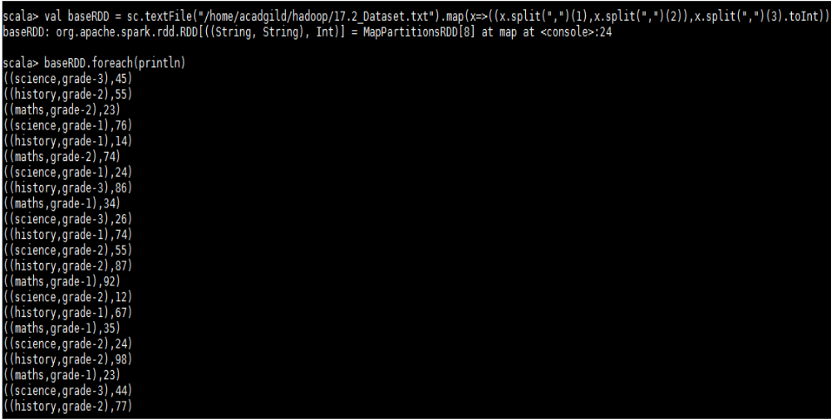

Then we are mapping the values of baseRDDwith numerical value 1 using function mapValues
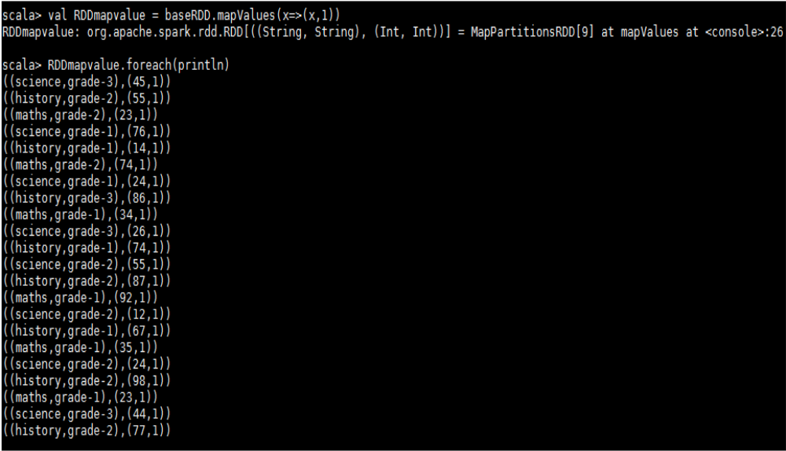

We are adding marks and number of occurrences for each key using reduceByKey
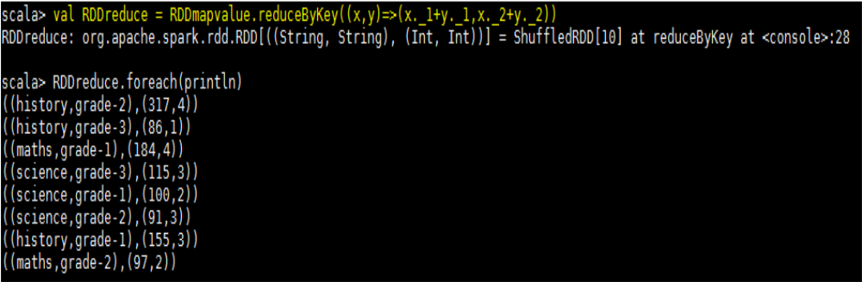
We are calculating average by dividing the sum of marks with number of occurrences and the requested
output is shown below
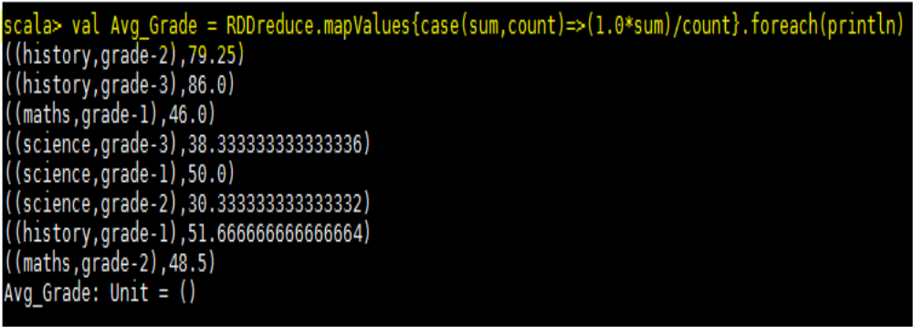

Task 2.5 - for all students in grade-2, how many have average score greater than 50?
Codes,
valbaseRDD =
sc.textFile("/home/acadgild/hadoop/17.2_Dataset.txt").map(x=>((x.split(",")(0),x.split(",")(2)),x.split(",")(3).toInt))

valRDDmap = baseRDD.mapValues(x=>(x,1))

valRDDreduce = RDDmap.reduceByKey((x,y)=>(x._1+y._1,x._2+y._2))

valRDDavg = RDDreduce.mapValues{case(sum,count)=>(1.0*sum)/count}

valRDDfiltermap = RDDavg.filter(x=>x._1._2 == "grade-2" && x._2>50).count()

valRDDfiltermap = RDDavg.filter(x=>x._1._2 == "grade-2" && x._2>50).foreach(println)

Creating a paired RDD named as baseRDD to read the file and extracting name and grade as key and
marks as value

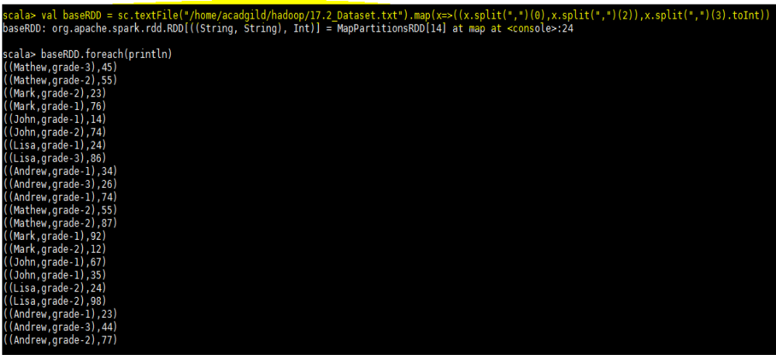

Now we are mapping each value of baseRDDwith 1 as shown below

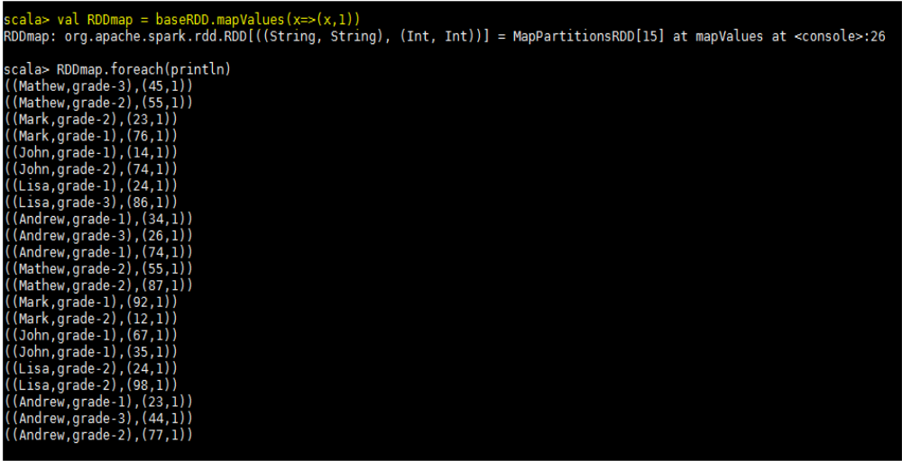

We are adding the marks of subject and number of occurrences per key using reduceByKeyfunction
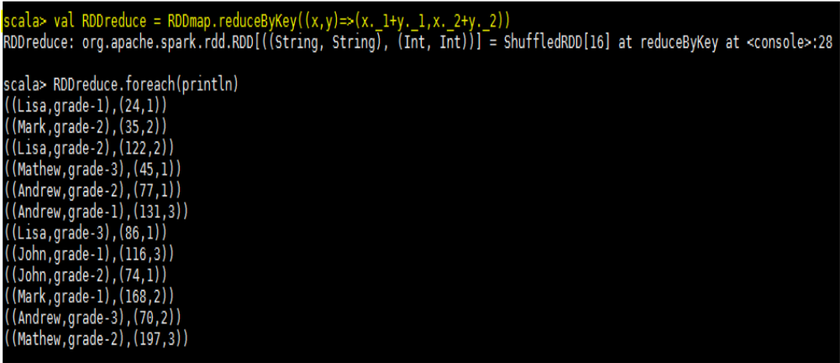

Here we are calculating the average of each student,
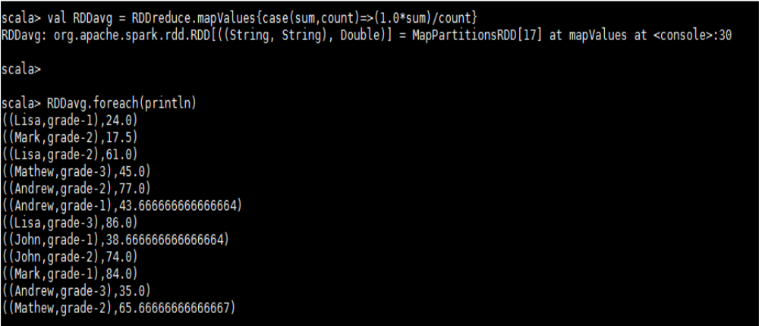

Now in below step we are filtering the above result with student belonging to grade-2 and having marks greater than 50, the number of the counts and the data is shown in the below
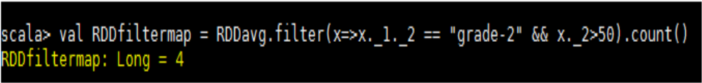
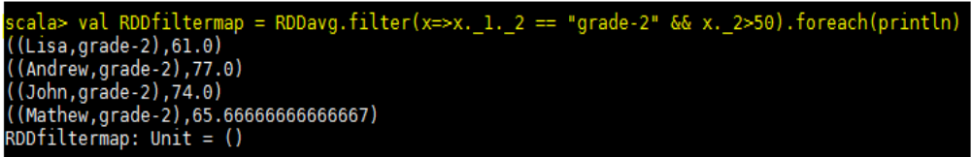

Spark Operations – Problem Statement 3

Are there any students in the college that satisfy the below criteria:
1. Average score per student_name across all grades is same as average score per student_name
per grade

Solution- To find the solution of above problem we will first calculate average of each student across all grades i.e. irrespective of grade. Below is the code used to find the same
valbaseRDD1 =
sc.textFile("/home/acadgild/hadoop/17.2_Dataset.txt").map(x=>(x.split(",")(0),x.split(",")(3).toInt))

valstudAvg = baseRDD1.mapValues(x=>(x,1)).foreach(println)

scala>valstudReduce = studAvg.reduceByKey((x,y)=> (x._1+y._1,x._2+y._2))

scala>valAvg_Stud = studReduce.mapValues{case (sum,count) => (1.0 * sum)/count}

We created a paired RDD named as baseRDD1 by extracting only name and marks,
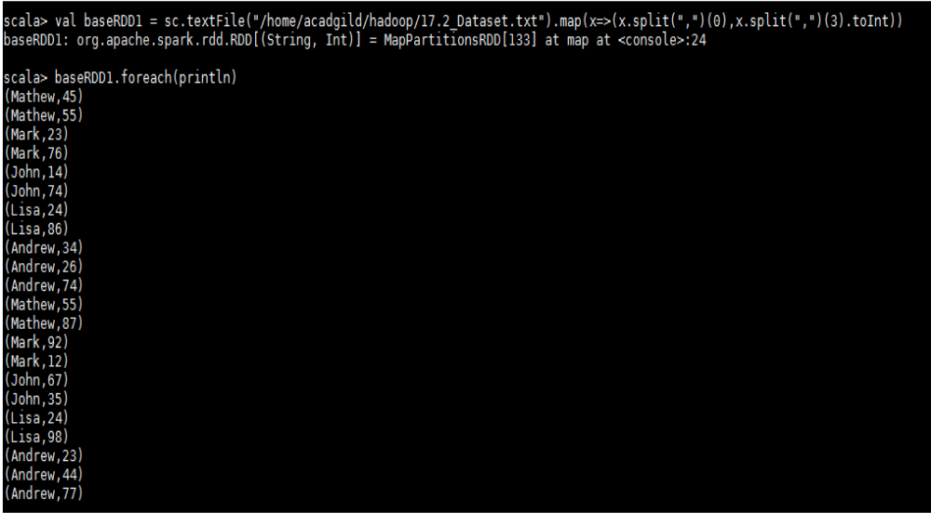

Then we are mapping each value of above RDD with 1,
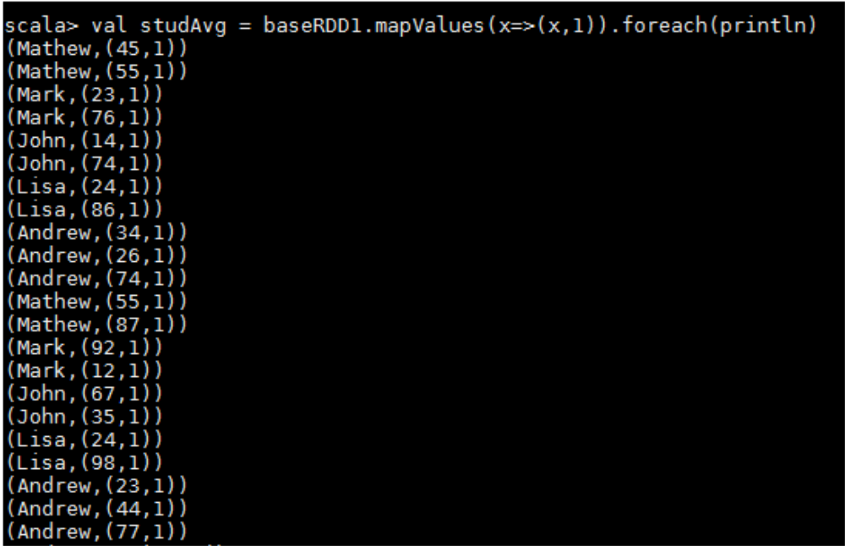

Then we are adding the marks and number of occurrences for each student using redducebyKeyas
shown below,
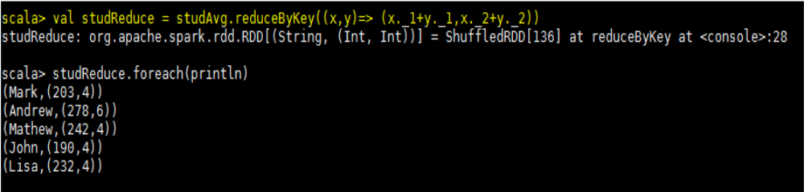

In below step we are calculating the average of each student,

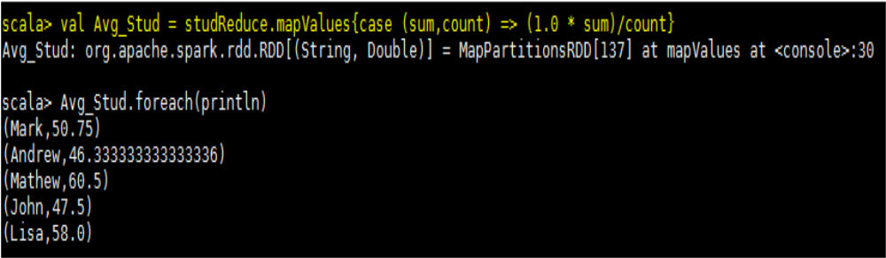

Now the second step of this problem is to find the average of each student per grade. We have used
below code to find,

valbaseRDD2 =
sc.textFile("/home/acadgild/hadoop/17.2_Dataset.txt").map(x=>((x.split(",")(0),x.split(",")(2)),x.split(",")(3).toInt)).foreach(println)

valgrade = baseRDD2.mapValues(x=>(x,1))

valgradeReduce = grade.reduceByKey((x,y)=> (x._1+y._1,x._2+y._2))

valgradeAvg = gradeReduce.mapValues{case(sum,count) => (1.0*sum)/count}

So first we are creating another paired RDD named as baseRDD2 by extracting name and grade as key
and marks as value from the input file,

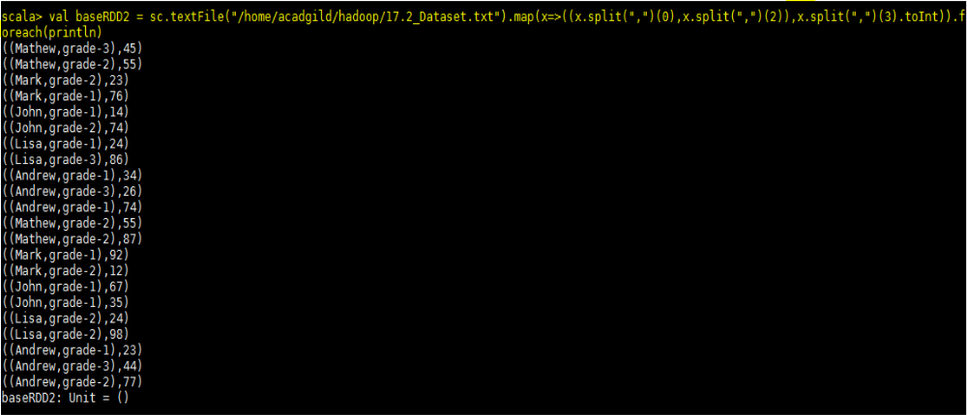

Then we are mapping each value of baseRDD2 with 1 using mapValuesfunction
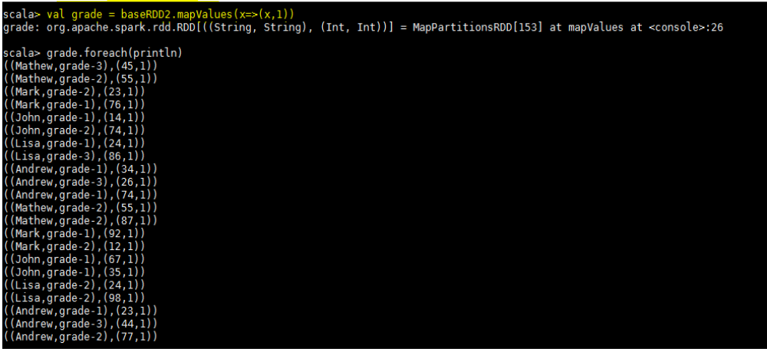

Then we are adding the marks and number of occurrences of 1 for each key using reduceByKey() function

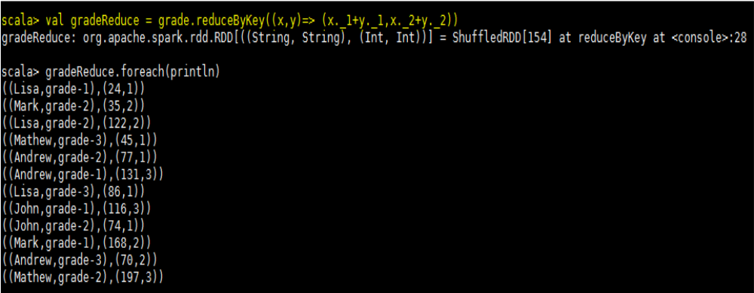

In below step we are calculating average of each key by dividing the sum of marks with the count

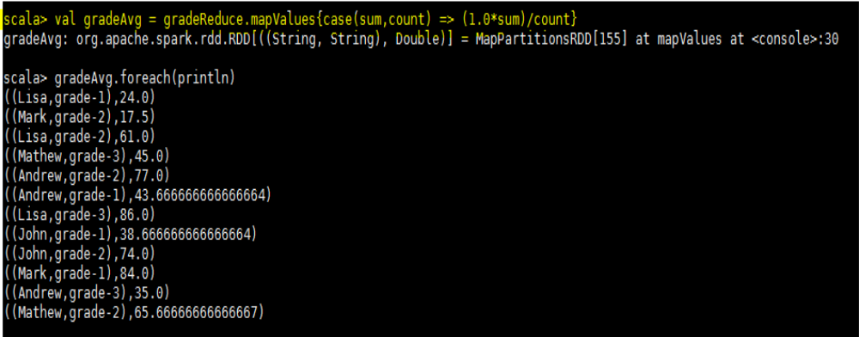

Now to proceed further we are extracting name and marks from above RDD,

In below step we are using intersection function between flatgradeAvg and flatnameAvgrdd’s to find
whether any common student is there.

scala>valflatgradeAvg = gradeAvg.map(x=> x._1._1 + "," + x._2.toDouble)

scala>valcommanval = flatgradeAvg.intersection(flatAvg_Stud)

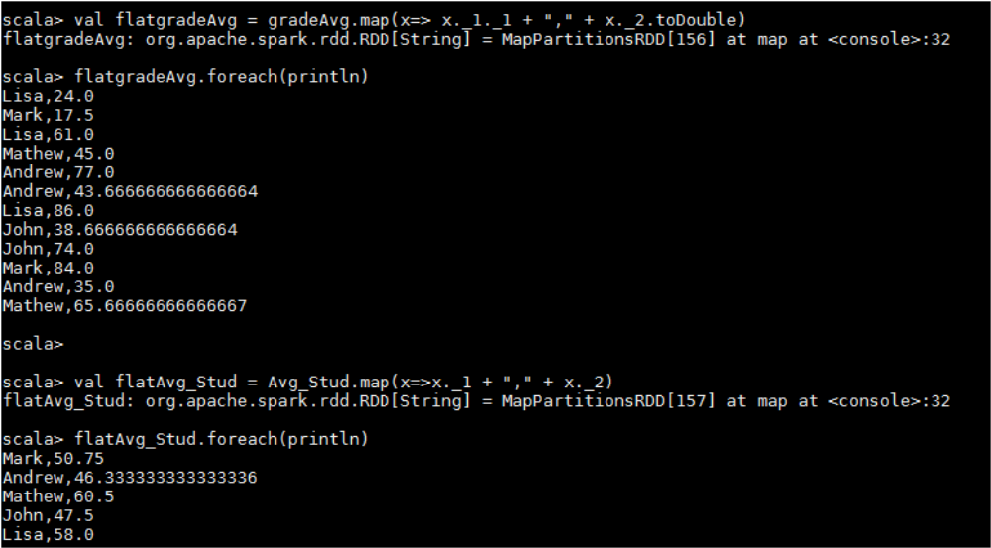

So the command comman.foreach(println) shows that no common students are there having average score per student_name across all grades is same as average score per student_nameper grade

